**Chapter I**

**Introduction**

**1.0 Introduction**

Shoe Mart (SM) Hotels was established to address the vast potential of tourism in the Philippines. Its vision and mission is to build world-class businesses that are catalysts for development in the communities they serve and partner with their host communities to provide a consistently high standard of service to their customers, look after the welfare of their employees and deliver sustainable returns to their shareholders, at all times upholding the highest standards of corporate governance in all their businesses.

* 1. **Project Context**

Inspection, maintenance, repair and other services are keys to a smooth and efficient flow of processes in a hotel. Having a high-quality equipment is no guarantee of optimum functionality and efficient processes. It is just as significant to have a new product properly installed and assembled as to have your products inspected and to get repairs or maintenance activities done at the right time.

The quality and safety of the processes can be controlled by having an application for inspection. In this way, it can inform the Quality Assurance (QA) management about the insufficiency of facilities, non-functioning of equipments and risks relating to safety.

The Shoe Mart (SM) Hotels team meets customer needs, primarily as an advisor on the kind of service program needed. The team can also provide actual inspection services, carried out by certified and well-experienced people. Generally, the team has the skills to carry out maintenance and repairs on the hotel facilities and on other amenities.

The Inspection Application enables hoteliers to manage all inspections from a smartphone. Once the inspection process is done, the app will automatically mail the data to the management. The Inspection Application is important to easily conduct all the inspections rather than the traditional inspection process that uses paper-based checklist. Inspection Application makes the inspection easier by generating electronic check list in an organized manner. It also makes the inspection paper-less.

The Inspection Application generates a report. The report shows the overall status of each equipment. It will inform the management the status of each facility rooms and if needed, identify the problems on each room.

* 1. **Purpose and Description**

Permits duty inspector to conduct all inspections from a smartphone and automatically submit the completed inspection results to the Quality Assurance (QA) management. In addition, inspection reports are stored for improvement and future references.

The main purpose of inspection is to provide quality assurance, condition of the systems and components of every facilities of the hotel that are defective or insufficient and need immediate attention, that could have a deleterious effect on the building and its occupants or economic value or marketability of the property. Conditions may be safety concerns, damage, insufficiency or deterioration of hotel components and facilities, anticipated problem due to existing defects or age of hotel component and equipment.

Inspection is the most common technique of retaining standardization, uniformity and quality. It is the function of quality control. If something does not fall within the zone of acceptability or standards it will be rejected and corrective measure will be applied to see that the items in future conform to specified standards. Inspection is an important tool of modern manufacturing process. It helps to control quality, reduces manufacturing. It is the cost art of controlling the product quality after comparison with the established costs, eliminate scrap losses and assignable causes of defective work.

* 1. **Objectives**

**1.3.1 General Objective:**

The primary objective of this study is to design an inspection application. That aims to improve the mobility of inspection and produce an accurate report such as in the attendance of employees. A Quick Response (QR) Code feature will be used. Generate an analytical report and display electronic checklists.

**1.3.2 Specific Objectives:**

* Aim for 100% quality of inspection.
* Inspection process to be minimize to 10 minutes from 20 minutes.
* To develop an application that provides time in and time out to monitor the attendance of each available inspector.
* To monitor the duty inspector’s time in and time out using the H2H (Hotel to Home) application.
* To use Quick Response (QR) Code as a trigger to start and end the inspection.
* To generate an analytical report regarding the status of each facility of the Hotel.
* To assure the management the real time of every duty inspector.
  1. **Scope and Limitations**

The project intends to inspect facilities using an application on a mobile phone. The project will be implemented at SM Hotels. Specifically, the back-end users will be the QA Department and the front-end users will be the duty inspector. These duty inspectors include the Engineering or the Maintenance team, Duty manager, and Security. The Inspection Application will give the facilities information which are type, status, location, quality of equipment in the facility, and urgency.

The Inspection Application will inspect on maintenance inspections, safety or regulatory inspections, and amenities inspections. The checklist on the Inspection Application will contain what the QA Department have generated. The inspection application also has the scheduling and generates report. The quality of each equipment in the facility will be labeled as *good, repair,* and *replace.* The label, ‘good’ is used to refer to equipment that is fully functioning with no issues or risk detected; the repair label is used to indicate that the equipment is partially damaged but can be fixed; and the replace label is used to indicate that the equipment is totally damaged and with high risk.

The application generates a summary inspection report on the quality of the utilities and amenities in each facility, this information could serve as basis on which things are needed to be improved or what facility issues need to be resolved. The inspection report will go immediately to the QA Department.

The Inspection Application also stores all required information in a database. It will store the daily, weekly, monthly and yearly reports. It will only store the reports for future references.

**Chapter II**

**Review of Related Literatures**

**2.1 Quality Assurance**

Susan Aryee conducted a study entitled HOTEL MAINTENANCE MANAGEMENT (Strategic practices in hotel operation) based on quality assurance. The researcher aims to seek maintenance management to pursuit the objective of analysing change management procedures accompanying the acquisition and installation of fixtures, find out challenges faced by hotel operators whilst implementing strategies to attain efficiency, and make recommendations for the way forward for hotel operators in general. (Susan Aryee, 2009. Hotel Maintenance Management (Strategic practices in hotel operation) based on quality assurance)

Des and Turkson conducted a case study on Quality Assurance in the Hospitality Industry for Hotels. The researchers aim to identify the link between quality and customer satisfaction, and find out the benefits of ensuring quality in the hospitality business for hotels. The research study has meaningful and great significance to academia. Thus, the research work contributes to existing knowledge on this study or a study of similar nature. (Des & Turkson, 2012. Quality Assurance in the Hospitality Industry for Hotels)

The software helps to increase facilities utilization and improves the effectiveness of a distributed workforce. It also provides move management capabilities for more efficient personnel and asset relocation. (IBM, 2003. ISS Turns to IBM Watson IoT to Transform Management of 25,000 Buildings Worldwide)

Manage facilities, including power and communications equipment, in line with laws and   regulations, technical and business requirements, vendor specifications, and health and safety guidelines. (ISACA, 2015. DS12.5 - Physical Facilities Management)

Piccoli conducted a study on Information Technology in Hotel Management states that Information technology can provide hospitality firms with a sustained competitive advantage, provided the technology complements operations. The chief element in achieving a competitive advantage is to identify the drivers of response lag, which is the time it takes for competitors to imitate an IT initiative—if they are able to do so. (Piccoli, 2010. Information Technology in Hotel Management)

Hotel ServicePro is an application that manage all the hotel system, it also automes the communicating in the entire hotel. Hotel ServicePro provides a platform for conducting consistent inspections. It allows the scheduling of inspections, provides reports and helps management identify training opportunities for team members. Increase and improve quality assurance inspection scores by your franchise representative. (Hotel ServicePro. Retrieved on March 13, 2017 / Retrieved from Hotel ServicePro: <http://www.hotelservicepro.com/about.htm>)

**2.2 Customer Service**

It is the view of business executives that retailers such as hotels that offer many customer services (delivery, gift wrapping, more pleasant surroundings, and sales assistance) satisfy their customers more than their competitors, arguing that it ensures and build an acceptable level of confidence of service offered to customers and promote assurance of quality. Securing also facility managements helps boost customers trust. Many consumers are willing to pay for more extra service as long as it provides the needed satisfaction to them. (Dunne,1999. Quality assurance in the hospitality industry ghanaian standpoint).

Donald (1994) indicated that it is important to know what customers expect to satisfy them. According to him knowing what customers expect is influenced by what marketers have promised in their advertisement and how well their expectations are being satisfied. (Donald, 1994. Measuring Customer Satisfaction with Service Quality Using American Customer Satisfaction Model (ACSI Model))

Dunne (1999) defines customer services as activities performed by retailers (hotels) that influence the ease with which a potential customer can learn about the firm’s offering, the ease with which a transaction can be completed once the customer attempts to make a purchase, and the customer’s satisfaction with the purchase. When the service is conducted professionally, accurately, promptly and in a good environment as expected by the customer then he or she becomes satisfied. When the service delivered is bad customers will always be dissatisfied. (Dunne, 1999. Quality assurance in the hospitality industry ghanaian standpoint)

Berman (2002) defines customer service as service which involves the identifiable but relative intangible, actions undertaken by a seller in conjunction with the basic goods or services it offers. He continues to say that the level of customer service provided by a firm can affect it ability to attract, assure and retain customers more than ever before. (Berman, 2002. The 5 Service Dimensions All Customers Care About)

According to Berkwowitz et al (2000) customer service is the ability of a logistics system to satisfy users in time, dependability, communication and convenience. He continues to say that customer service is not merely seen as an expense but a strategic tool for increasing customer satisfaction. (Berkwowitz et al, 2000. The three Cs of customer satisfaction: Consistency, consistency, consistency)

Xu and Chan from Hongkong conducted a study entitled A conceptual framework of hotel experience and customer‐based brand equity: Some research questions and implications. The researcher’s aim was to review the hospitality and brand equity literature, thereby providing a conceptual framework for understanding hotel brand equity. The findings showed that hotels often use advertising, referral marketing and services marketing to help guests acquire brand‐related information. Hotel guests, in turn, establish their brand knowledge through direct and indirect experiences. (Xu & Chan, 2010. A conceptual framework of hotel experience and customer‐based brand equity)

Solnet from Australia conducted a study entitled Introducing employee social identification to customer satisfaction research: A hotel industry study. In which the findings of this study provided management with useful information about the important role of service climate and the way in which managers can capitalize on employee identification to enhance organizational practices, which can flow on to customer outcomes. (Solnet,2006. Introducing employee social identification to customer satisfaction research)

Hilliard & Baloglu conducted a research about why is Safety and Security as Part of the Hotel Servicescape for Meeting Planners. The study examines how hotel safety and security attributes influence the site-inspection practices of meeting planners, and the relative importance of hotel safety and security attributes in influencing a meeting planner's decision to choose a hotel as the site for a meeting as well as her/his willingness to pay more for a hotel with safety and security certification. The study also explored the relationship of meeting planners' experience level and the nature of the meetings they plan in relation to the importance they place on hotel safety and security attributes. (Hilliard & Baloglu, 2013. Why is Safety and Security as Part of the Hotel Servicescape for Meeting Planners)

**2.3 Facility Management**

The International Facility Management Association (IFMA), the World’s leading FM professional body, defines FM as, ‘A profession that encompasses multiple disciplines to ensure functionality of the built environment by integrating people, place, process and technology.’ That sounds a bit long winded but it accurately identifies the management of multi-disciplines through people, process and technology. (Wallace, 2012. International Facility Management Association (IFMA))

Facilities include areas that are constructed or maintained to allow people to participate in sport and recreation activities, such as a pool, gym or oval, as well as any structures that support people involved in sport and recreation, such as a change room, canteen, grandstand or scoreboard. A facility can be a large multi-use center with playing surfaces catering for different activities, or it may be a small hall or room catering for one specific activity. (Tasmania, 2009. Managing a sport and recreation facility)

Facility management is a profession that encompasses multiple disciplines to ensure functionality of the built environment by integrating people, place, process and technology. (Wagnon, 2012. The core competencies of facility management)

    Facilities management is the integration of processes within an organization to maintain and develop the agreed services which support and improve the effectiveness of its primary activities. Facilities management encompasses multi-disciplinary activities within the built environment and the management of their impact upon people and the workplace. (Wallace, 2012. British Institute of Facilities Management (BIFM))

The definition of Facilities Management is always evolving and many people and Organizations have different views. Your feedback and thoughts on the definitions below would be appreciated. A simple definition of Facilities Management is the integrated management of the work environment and supporting services of an organization to provide an environment that enables the business to achieve its primary objective. (Roper, 2014. British Institute of Facilities Management (BIFM) and International Facility Management Association (IFMA))

Facility management is the coordination of the physical workplace with the people and work of an organization. It is the integration of business administration, architecture, and the behavioral and engineering sciences. In the most basic terms, facility management encompasses all activities related to keeping a complex operating. (Price, 2005. The evolving character of facility management)

Integrated Facilities Management Systems (IFMS) is an IT based fiscal and financial management information system (budgeting and accounting system) that will assist government and other entities to initiate, spend and monitor their budgets, initiate and process their payments, and manage and report on their financial activities. It bundles the essential financial management functions into one suite of applications. (Wagnon, 2012. Integrated Facilities Management Systems (IFMS))

Facilities management can boost an organization’s image, enable new working styles and processes, and provide business continuity and workforce protection in an era of potentially heightened security threats. It can also be particularly important to an organization which needs to integrate its processes following a change such as a merger or an acquisition, or project manage a refurbishment or relocation of a company’s premises. (Payant, 2014. The Facility Management Handbook, 4th Edition)

Facility management is a multidisciplinary function requiring a deep knowledge of the entire business and physical planning cycle, including the buildings, infrastructure, and people. Technology systems, disaster recovery planning, zoning compliance, furnishings, recycling programs, grounds maintenance--it all falls under the facility management umbrella. The sheer scope of duties requires a far-reaching reference for staying abreast of the latest innovations and best practices. Insightful overviews, case studies, and practical guidelines pave the way for successful planning, budgeting, real estate transactions, construction, emergency preparedness, security, operations, maintenance, and more. This thoroughly revised fourth edition examines cutting-edge technologies and includes new information on Building Information Modeling (BIM), contracting and project management methods, FASB and IASB requirements, distributed working, and sustainability reporting. (Roper & Payant, 2014. The Facility Management Handbook, 4th Edition)

Since buildings count for half of the primary energy sources consumption as well as half of all consumed raw materials, produce hundreds of million tons of waste and a third of the world's CO2 production, construction and building of low energy buildings has become an international trend. More than transportation, mining industry, or any other type of industry it is primarily the area of building industry and building administration that lead to better management of narrow resources as well as to the reduction of greenhouse gases emissions. In this area facility management also plays an important role. The aim of the article is via analysis of building life cycle to present possibilities of the influence of a facility manager on the investment and running costs of buildings with respect to the environmental management principle. (Potkany, Vetrakova, & Babiakova,2015. Benefits of Green Building)

The importance of effective facility management in enabling organizations to function efficiently is widely recognized. The fourth edition of Total Facility Management offers a comprehensive treatment of what facility management means to owners, operators, tenants, facility managers and professional advisors, as well as containing advice on how facilities can be better managed from a number of perspectives. It consolidates current best practice, defines and develops emergent areas and offers a pathway for the future development of facility management. (Atkin & Brooks, 2016). Building owners and facility managers are discovering that Building Information Modeling (BIM) models of buildings are deep reservoirs of information that can provide valuable spatial and mechanical details on every aspect of a property. When used appropriately, this data can improve performance and save time, effort, and money in running and maintaining the building during its life cycle. It can also provide information for future modifications. For instance, a BIM could reveal everything from the manufacturer of a light fixture to its energy usage to maintenance instructions. (Teicholz, 2013. Total Facility Management).

Topics covered deal with the changes occurring in the field today and include key research areas for both academics and practitioners. The focus is on actual practice of Facility Management organizations – rather than on what Facility Management should be - and the authors examine the latest techniques, models and case studies to provide a unique exploration of the new global world of facility management. (Roper & Borello, 2014. Facility Management organizations)

This provides a readily accessible and practical guide to the increasingly important subject of facilities management. It shows the formal basis for the complex and constantly moving requirements of Facility Management and recognizes that it is becoming more vital in its role of enabling the core business of a company to function effectively. (Barker, 2014. A Practical Guide to Facilities Management).

Facility Management covers many topics that are absolutely essential to sustainability -- some of them covered in no other text. Embracing multiple subject areas, it can easily be used as the main text for a capstone course of a facility management degree program. Topics covered include: organizational structure; cultural issues associated with property/facility management; career opportunities; financial, construction, and emergency management; environmental issues; HVAC, energy, and water management; green building; strategic management, and more. Throughout, chapter questions, assignments, photos, and diagrams help students deepen their understanding. These are complemented by many first-hand insights about effective facility management. (Fennimore, 2014. Sustainable Facility Management: Operational Strategies for Today).

Facility Management provides comprehensive guidance to those involved in the refurbishment and management of existing buildings on minimizing carbon emissions, water consumption and waste to landfill, along with enhancing the long term sustainability of a building. (Appleby, 2013. Sustainable Retrofit and Facilities Management).

Facilities Management (FM) of hospitals and healthcare facilities, which are among the most complex, costly and challenging kind of buildings to manage. It presents and evaluates the FM service quality standards in Singapore’s hospitals from the patient’s perspective, and provides recommendations on how to successfully improve FM service quality and achieve higher patient satisfaction. (Pheng, & Rui, 2016. Facilities Management (FM) of hospitals and healthcare facilities).

Facilities management is a broad-based discipline that calls into play architectural, construction, engineering, and management and human skills-- particularly for running and maintaining commercial, institutional, academic, and industrial buildings. (Levitt, 2013. Facilities Management: Managing Maintenance for Buildings and Facilities)

Penny from China conducted a study on The use of environmental management as a facilities management tool in the Macao hotel sector. The paper provides a comprehensive discussion of the roles played by environmental management in improving a hotel's productivity and competitiveness and recommends ways to increase hoteliers' understanding of those roles. Penny finds that although low customer demand, poor environmental knowledge and the lack of governmental regulations enforcing environmental practices are the reasons hindering hoteliers in Macao from practicing green, the major barrier is that hotel managers do not recognize the importance of environmental management to hotel effectiveness and competitiveness. (Penny, 2012. The use of environmental management as a facilities management tool in the Macao hotel sector)

Kandampully a professor from University of Queensland, Australia conducted a research in Customer loyalty in the hotel industry: the role of customer satisfaction and image where in the study helps us extend our understanding of the relationship between customer loyalty, customer satisfaction, and image. This is of considerable interest to both practitioners and academics in the field of hospitality and facility management. (Kandampully,2000. Customer loyalty in the hotel industry)

QFM software is a facilities management where focusing in to planning, safety and maintaining building facilities. QFM is a fully integrated suite of web-based management software tools, providing a centralized view of facilities. QFM includes a mobile CMMS software solution, to enable remote workforce management using tablet or smart phone devices, with offline work management capabilities. (QFM Software. Retrieved on March 14, 2017 / Retrieved from QFM Software: https://www.swg.com/usa/subproducts/qfm-facilities/)

Asset Panda Facility Management Software is a mobile app that can create and manage work orders assigned to the user equipment simple. Asset Panda Software dashboard makes it easy to access asset info at a glance. Check in and check out. Download reports. Customizable alerts, electronic signatures, and auditing features increase accountability. No matter the industry, Asset Panda makes it easier to track items, manage actions associated with those items, stay current on maintenance, and easily document support records. (Asset Panda Facility Management Software. Retrieved on March 14, 2017 / Retrieved from Asset Panda Facility Management Software: <https://www.assetpanda.com/facilities-management-asset-tracking/>)

The Hippo feature are capabilities such as work order management, predictive and preventive maintenance, asset and equipment management, and resource and vendor management. The facilities maintenance software allows the user to accurately monitor building maintenance and ensure uptime of critical equipment and systems. The hippo can maintain a single building or a multi-level complex, Hippo can bring value to all of the user maintenance operations. (Hippo. Retrieved on March 15, 2017 / Hippo: https://www.hippocmms.com/industries/facility-management-software)

Gibson Hotel Management, Inc. property services personnel oversee all areas of FF&E, routine and long-term maintenance, energy management and energy efficiency reviews.  To maximize safety and minimize risk, Gibson Hotel Management, Inc. puts a comprehensive Risk Management program in place at every property we manage. The program includes annual audits by our Facility Director or third-party engineering technician, insurance carriers, and corporate personnel at each hotel that we manage. In addition, local management develops a risk manual for their facility, performs regular self-audits, and participates in safety training programs. Maintenance, energy management and energy efficiency reviews. (Gibson Hotel Management, Inc. Retrieved on March 15, 2017 / Gibson Hotel Management, Inc.: http://mgibsonhotels.com/services.html)

eSSETS Facilities Management Software (CAFM) is a cloud base software that has the features to save time, organized paperless system, reduce risk, and feedback system. eSSETS CAFM can handle growing portfolio of building and equipment. The software tools will help to improves efficientcy and effectiveness of maintaining any facilities. [Preventive maintenance](https://essets.com/preventive-maintenance-inspections-checklists) can be defined and scheduled at any level in the Place hierarchy. When sending a staff technician or contractor to a Place, managers and dispatchers can quickly lookup all the open [work orders](https://essets.com/work-orders-service-requests-preventive-maintenance) associated with the target place with multiple jobs. (eSSETS Facilities Management Software (CAFM). Retrieved on March 15, 2017 / eSSETS Facilities Management Software (CAFM): https://essets.com/Churches-Religious-Institutions-Facility-Management-Software#.WV0dHtSGPtQ)

AkitaBox’s facility management software provides an organized and integrated home for the user building’s plans, assets and maintenance records. It can also do heavy lifting and collect the information the user need for setting up a preventive maintenance or capital plan. All major assets of the facility will be tracked, photographed and pinned to a specific location on a floor plan. Akitabox integrates building plans, work orders and maintenance information to gives a single-source of truth for facility operations and planning. Rather than looking through a cluttered plan room or complicated software system, AkitaBox’s intuitive interface allows for speedy information retrieval by clicking locations on a floor plan or scanning QR codes. (AkitaBox’s facility management software. Retrieved on March 20, 2017 / AkitaBox’s facility management software: https://home.akitabox.com/)

CleanTelligent Facility Inspection software is a smartphone or tablet to perform inspections on the go. It can inspect easily amd select and rate the different facilities. Take photos of problem areas and attach them with additional comments.View reports of past inspections and identify the most common problems in specific areas. It can also determine the type of additional training the users inspectors. Create custom inspection forms with unique grading scales. Quickly filter for specific tasks by location and sub-location. Mark the most frequent or important facilities that needs to inspect. CleanTelligent also can set schedule to inspection to different facilities. (CleanTelligent Facility Inspection software. Retrieved on March 20, 2017 / CleanTelligent Facility Inspection software: <http://www.cleantelligent.com/solutions/>)

**2.3 Inspection Checklist**

Chernak from New Jersey, USA proposed a statistical approach to the formal synthesis and improvement of inspection checklists. The main advantage of the proposed technique is that it allows us to tune a checklist according to the most recent project experience and to identify optimal checklist items even when a source document does not exist. (Chernak,2012. Statistical approach to the formal synthesis and improvement of inspection checklists)

Brykczynski conducted a survey regarding software inspection checklists. The Software inspection processes call for a checklist to provide reviewers with hints and recommendations for finding defects during the examination of a work product. Different categories of checklist items are discussed and examples are provided of good checklist items as well as those that should be avoided. (Brykczynski,2008. Software inspection checklists)

Thelin, Runeson, Wohlin conducted an experimental research about comparison of usage-based and checklist-based reading. Software quality can be defined as the customers' perception of how a system works. Inspection is a method to monitor and control the quality throughout the development cycle. Reading techniques applied to inspections help reviewers to stay focused on the important parts of an artifact when inspecting. (Thelin, Runeson, & Wohlin, 2013. Comparison of usage-based and checklist-based reading)

Knight and Myers conducted a research study about an improved inspection technique in this research, existing software quality review methods are not always carried out rigorously and do not always achieve their full potential; the dependence on human efforts for reviews also limits their effectiveness. An enhanced method for software inspection called phased inspections is described; the technique is intended to allow the inspection process to be consistently rigorous, customizable, efficient in resource use, and supportable by computers. (Knight & Myers, 2017. An improved inspection technique)

AwareManager is the most comprehensible, fully integrated and flexible solution in the industry. Whether you need a simple work order management solution or require more advanced capabilities such as risk management or vendor governance, AwareManager has you covered. Our team works alongside our clients to make it easier for everyone involved - managers, engineers, tenants, vendors, and visitors - leveraging what we've learned from the most innovative properties, hospitals and sports venues. (AwareManager. Retrieved on March 20, 2017 / AwareManager: https://www.awaremanager.com/)

MicroMain is an application from hotels, restaurants, and amusement parks to museums and stadiums this app help to facilitate and maintain the operations under control. MicroMain gives you the functionality such as visual work order scheduling, mobile access, and prioritization tools. In addition, preventive maintenance functions ensure regularly basis, keeping equipment and vehicles running efficiently and areas neat and clean in the facilities. (MicroMain. Retrieved on March 20, 2017 / MicroMain: https://www.micromain.com/)

Maintenance Pro can track an unlimited number of pieces of equipment. Automated and color-coded preventive maintenance alerts will automatically display upon program startup. Repair maintenance tracking is essential to the user’s equipment management. Maintenance Pro enables the user to track and monitor trends in repair maintenance, so you can decide whether to keep or retire a piece of equipment.  As the user close work orders and record maintenance for the user equipment, Maintenance Pro maintains a detailed maintenance history. The built-in report designer can easily make adjustments to any of the stock reports included with Maintenance Pro. (Maintenance Pro. Retrieved on March 20, 2017 / Maintenance Pro: http://www.mtcpro.com/maintenance-pro.htm)

**Chapter III**

**Technical Background**

**3.1 Programming Language:**

**3.1.1 Android Platform**

For the platform, we suggest to use Android. Google’s Android Operating System in Mobile phones are still relatively new. Android Studio is an IDE that is specifically developed to make Android Apps which is based on IntelliJ IDEA –an IDE used to develop computer software. Android Studio offers an easy developing environment since it lets developers customize templates or make their own.

However, Android Operating System has been progressing quite rapidly. Conceived as a counterpoint IOS, Android is a graph showing a significant development; it certainly cannot be separated from supports major mobile phone manufacturers who participated in bringing mobile-phone operating system Android.

**IDE that will be used: Android Studio**

For the Integrated Development Environment (IDE), we propose to use the Android Studio. At present, more than 76.6% of the Smartphones, including HTC, LG and Samsung models use Android as their operating system (OS). It is also expected that Android will be used in smart watches, laptops and cars very soon. Android powered devices including tablets have become the foremost need of all the tech-savvy people across the world. The prime reason for this is that it provides an open source platform for the development of great apps plus allows application developers to immediately publish their application. Instead, lots of developers want to get associated with Android application because of incredible growth.

**3.1.2 Oracle for Database**

The SM Hotels uses the Oracle database. Oracle Database (commonly referred to as Oracle RDBMS or simply as Oracle) is an object-relational database management system produced and marketed by Oracle Corporation. In that way, Hotel 2 Home Inspection Application uses the same database as the Shoe Mart (SM) Hotels and Convention and since all the project will be integrated it would be easier for the students to collaborate their systems. Oracle’s latest database cloud innovations help more businesses than ever leverage industry-leading enterprise capabilities while simplifying access for IT and developers. New data management capabilities enable companies of all sizes to confidently and easily migrate workloads to the cloud. Its massive cloud scalability and rapid analytics help deliver faster time to insights, greater agility, and real cost savings advantages.

**3.2 Resource Requirements:**

**3.2.1 Hardware Requirements**

Since Android is the platform to be used, the proposed application in this project will be running on Android smartphones. Inspection is tedious so we need to develop a software that will be available on smart phones that inspectors can carry anytime, anywhere.  Working with Android devices is the best choice for making an application since Android gives their clients and unique engineers unlimited possibilities for the devices modification to whatever the client needs to have. It will not work on iOS (Apple) users since it will be programmed using Android Studio.

**3.2.2 Software Requirements**

- At least an android version of 4.0 (Ice Cream Sandwich), 1 Gigabyte RAM, single core (1 Giga hertz)

- At least 8 Megapixel (MP) back camera and needs autofocus feature.

**3.2.3 Computer Devices**

Quality Assurance Department use the computer device. It is used to format and edit data in the inspection application.

**3.2.3.1** **Computer Specification:**

At least dual core processor and 2 gigabyte RAM.

**Chapter IV**

**The Existing System**

**4.1 Company Background**

SM Hotels and Conventions Corporation (SMHCC) was established to address the vast potential of tourism in the country. It is now developing and operating hotels and convention centers all throughout the archipelago with a current portfolio of 1,514 rooms housed in the 261-room Taal Vista Hotel, a heritage hotel located in Tagaytay City; the 154-room Pico Sands Hotel in Hamilo Coast; and the 347-guestroom deluxe 5-star hotel, Conrad Manila, located in the Mall of Asia Complex.

All these allow guests to experience luxury and the world-renowned Filipino hospitality, made more memorable by the natural beauty of their surrounding landscapes.

SMHCC operates convention centers and trade halls through SMX Convention Center (SMX), which has become a popular venue for both local and international events. Setting the bar in upscale convention facilities, SMX provides an ideal venue for large-scale institutional events, town hall meetings, weddings, exhibits, and concerts in many cities across the country.

**4.2 Description of the System**

Inspection is to provide quality assurance, condition of the systems and components of every facilities of the hotel that are defective or insufficient and need immediate attention, that could have a deleterious effect on the building and its occupants or economic value or marketability of the property. Conditions may be safety concerns, damage, insufficiency or deterioration of hotel components and facilities, anticipated problem due to existing defects or age of hotel component and equipment.

Inspection is the function of quality control. If something does not fall within the zone of acceptability or standards it will be rejected and corrective measure will be applied to see that the items in future conform to specified standards. Inspection is an important tool of modern manufacturing process. It helps to control quality, reduces manufacturing. It is the cost art of controlling the product quality after comparison with the established costs, eliminate scrap losses and assignable causes of defective work.

**4.3 Data Flow Diagram**

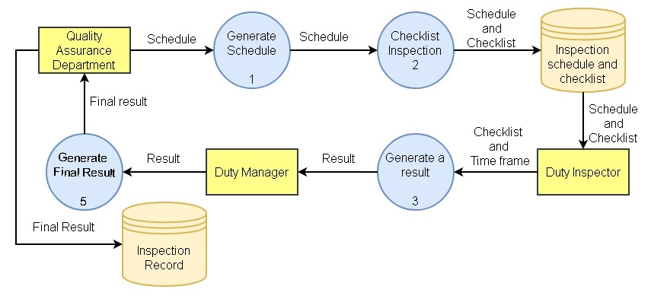

Figure 4.1 Existing Data Flow Diagram of Facilities Inspection

The diagram shows that the data flow will start when Quality Assurance Department generate schedule and checklist for the duty inspector. Schedule and checklist will be stored. When the duty inspector is done with the inspection, the result and the period of inspection will be passed to the duty manager to check and finalize. After finalizing the result, it will be back to the QA Department and store to the database.

**4.4 Data Dictionary**

Inspector Table

|  |  |  |
| --- | --- | --- |
| Field Name | Caption | Data Type |
| INSPECT_ID | Inspector’s Identification | INT |
| INSPECT_LastName | Inspector’s Last Name | VARCHAR(45) |
| INSPECT_FirstName | Inspector’s First Name | VARCHAR(45) |
| INSPECT_Number | Inspector’s Number | INT |
| INSPECT_Email | Inspector’s Email | VARCHAR(45) |
| INSPECT_Occupation | Inspector’s Occupation | VARCHAR(45) |

Schedule Table

|  |  |  |
| --- | --- | --- |
| Field Name | Caption | Data Type |
| SCHED_Number | Schedule’s Number | INT |
| SCHED_Date | Schedule’s Date | DATETIME |

Checklist Table

|  |  |  |
| --- | --- | --- |
| Field Name | Caption | Data Type |
| CHECK_Number | Checklist’s Number | INT |
| CHECK_Equipment | Checklist’s Equipment | VARCHAR(45) |
| CHECK_QuantityOnHand | Checklist’s Quantity | INT |
| CHECK_Status | Checklist’s Status | VARCHAR(45) |

Facilities Table

|  |  |  |
| --- | --- | --- |
| Field Name | Caption | Data Type |
| FACILITY_RoomID | Facility’s Room Identification | INT |
| FACILITY_Type | Facility’s Type | VARCHAR(45) |

Table 4.1 Existing Data Dictionary of Facilities Inspection

**4.5 Problem Areas**

The assurance that SM Hotel inspectors to do the inspection carefully is the main concern of this project. SM Hotels wants to monitor the Duty Inspector and assure the quality of each facility of the hotel. Also, SM Hotels could not address the issue immediately because of how the existing system runs, before the result will be submitted the Duty Inspector needs to inspect each of every room so, it take time before the issue will be address.

**Chapter V**

**The Proposed System**

**5.1 System Overview**

The Inspection Application enables hoteliers to manage all inspections from a smartphone. Once the inspection process is done, the app will automatically mail the data to the management. The Inspection Application is important to easily conduct all the inspections rather than the traditional inspection process that uses paper-based checklist. Inspection Application makes the inspection easier by generating electronic check list in an organized manner. It also makes the inspection paper-less.

The application generates a summary inspection report on the quality of the utilities and amenities in each facility, this information could serve as basis on which things are needed to be improved or what facility issues need to be resolved. The inspection report will go immediately to the QA Department.

The Inspection Application generates a report. The report shows the overall status of each equipment. It will inform the management the status of each facility rooms and if needed, identify the problems on each room.

**5.2 Process Specification**

**5.2.1 Data Flow Diagram**

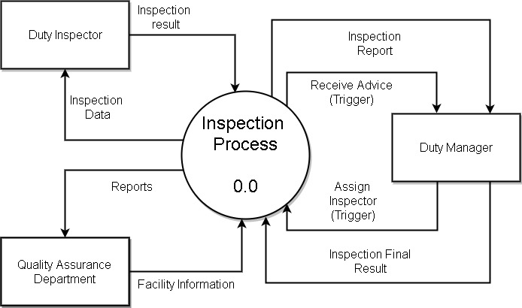

Figure 5.1 Proposed Data Flow Diagram Level 0 of Facilities Inspection

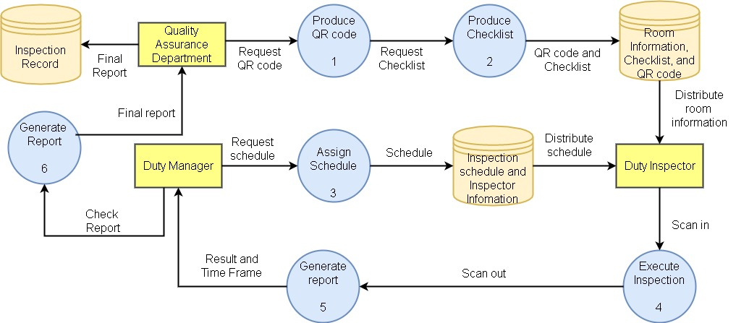

Figure 5.2 Proposed Data Flow Diagram Level 1 of Facilities Inspection

Figure 5.3 Proposed Data Flow Diagram Level 1 of Emergency Facilities Inspection

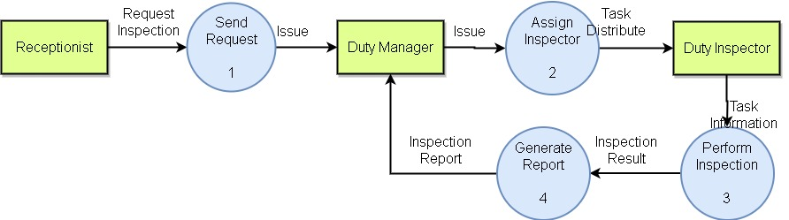The diagram shows that the data flow will start when Quality Assurance Department produce QR code and checklist for the duty inspector. QR code and checklist will be stored in the room information, checklist and QR code database. Quality Assurance Department will also assign schedule for the duty inspector. Schedule will be stored in the inspection schedule and inspector information database. The duty inspector will start as soon as receiving the room information and schedule. When the duty inspector is done with the inspection, the result and the period of inspection will be passed to the duty manager to check and finalize. After finalizing the result, it will be back to the QA Department and store to the database.

**5.2.2 Data Dictionary**

Abbreviated Words

|  |  |
| --- | --- |
| Word | Meaning |
| H2H | Hotel to Home |
| QA | Quality Assurance |
| QR | Quick Response |
| SM | ShoeMart |
| SMHCC | ShoeMart Hotels and Conventions Corporation |

Inspector Table

|  |  |  |
| --- | --- | --- |
| Field Name | Caption | Data Type |
| INSPECT_ID | Inspector’s Identification | INT |
| INSPECT_LastName | Inspector’s Last Name | VARCHAR(45) |
| INSPECT_FirstName | Inspector’s First Name | VARCHAR(45) |
| INSPECT_Number | Inspector’s Number | INT |
| INSPECT_Email | Inspector’s Email | VARCHAR(45) |
| INSPECT_UserType | Inspector’s User Type | VARCHAR(45) |
| INSPECT_Occupation | Inspector’s Occupation | VARCHAR(45) |

Schedule Table

|  |  |  |
| --- | --- | --- |
| Field Name | Caption | Data Type |
| SCHED_Number | Schedule’s Number | INT |
| SCHED_Date | Schedule’s Date | DATETIME |

Checklist Table

|  |  |  |
| --- | --- | --- |
| Field Name | Caption | Data Type |
| CHECK_Number | Checklist’s Number | INT |
| CHECK_Equipment | Checklist’s Equipment | VARCHAR(45) |
| CHECK_QuantityOnHand | Checklist’s Quantity | INT |
| CHECK_Status | Checklist’s Status | VARCHAR(45) |

Facilities Table

|  |  |  |
| --- | --- | --- |
| Field Name | Caption | Data Type |
| FACILITY_RoomID | Facility’s Room Identification | INT |
| FACILITY_Type | Facility’s Type | VARCHAR(45) |
| FACILITY_QRCode | Facility’s QR Code | VARCHAR(45) |

Table 5.1 Proposed Data Dictionary of Facilities Inspection

**5.3 Data Specification**

**5.3.1 Entity-Relationship Diagram**

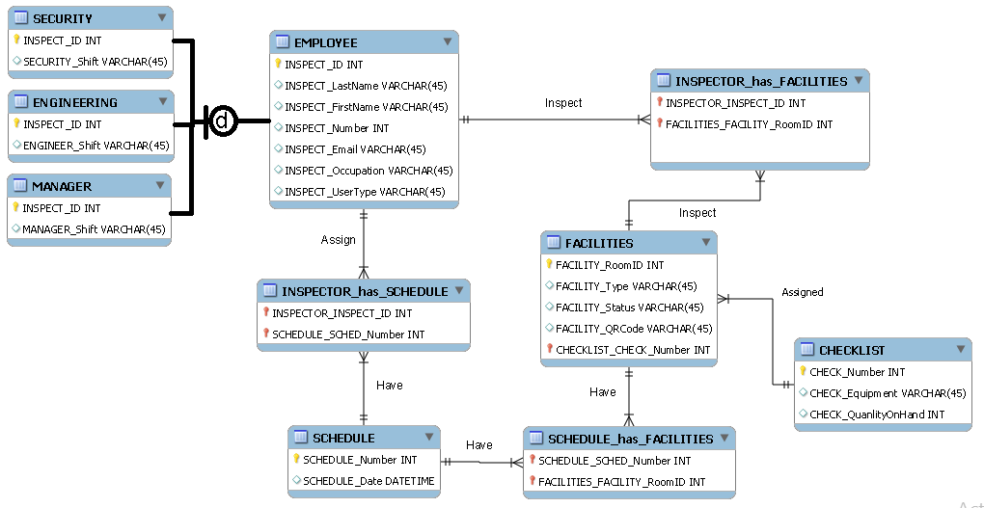

Figure 5.4 Entity-Relationship Diagram of Facilities Inspection

SM Hotels business process works 24 hours a day. Each day has 3 shifts, every shift one of the duty inspector will inspect the scheduled facilities. The duty inspectors are the hotel securities, engineers, and duty managers. Duty inspector will assign more than one schedule and every date in the schedule has several duty inspectors. Facilities can be inspected in different schedule and one date in schedule may have different facilities. Checklist may assign to several facilities but facilities may only have one checklist assigned.

**5.3.2 Tables/Files Layout**

Inspector Table

|  |  |
| --- | --- |
| Item | Description |
| INSPECT_ID | Inspector’s Identification |
| INSPECT_LastName | Inspector’s Last Name |
| INSPECT_FirstName | Inspector’s First Name |
| INSPECT_Number | Inspector’s Number |
| INSPECT_Email | Inspector’s Email |
| INSPECT_UserType | Inspector’s User Type |
| INSPECT_Occupation | Inspector’s Occupation |

Schedule Table

|  |  |
| --- | --- |
| Item | Description |
| SCHED_Number | Schedule’s Number |
| SCHED_Date | Schedule’s Date |

Checklist Table

|  |  |
| --- | --- |
| Item | Description |
| CHECK_Number | Checklist’s Number |
| CHECK_Equipment | Checklist’s Equipment |
| CHECK_QuantityOnHand | Checklist’s Quantity |
| CHECK_Status | Checklist’s Status |

Facilities Table

|  |  |
| --- | --- |
| Item | Description |
| FACILITY_RoomID | Facility’s Room Identification |
| FACILITY_Type | Facility’s Type |
| FACILITY_QRCode | Facility’s QR Code |

Table 5.2 Tables/Files Layout of Facilities Inspection

**Chapter VI**

**Methodology**

**6.1 Other Diagrams**

**Conceptual Framework**

Schedule

Checklist

Inspector

Facilities

Result

Figure 6.1 Existing Conceptual Framework of Facilities Inspection

The diagram shows that the system process will start if schedule together with checklist assign to duty inspector. The duty inspector will only inspect the facilities base on schedule and must provide a result.

**Conceptual Framework**





Report

Checklist





Inspector

Facilities

H2H Application



Schedule

Result

Figure 6.2 Proposed Conceptual Framework of Facilities Inspection

The diagram shows that the proposed system will be synchronized. The assigned schedule, facilities, and checklist will be stored in H2H Application. The duty inspector can access the H2H Application to see and review all the assigned schedule and facilities to inspect. Also, the H2H Application can provide the checklist for each facility and use it to inspect. After inspection, the duty inspector report will be gather by H2H Application and generate and result of all data gathered.

**Use Case Diagram**

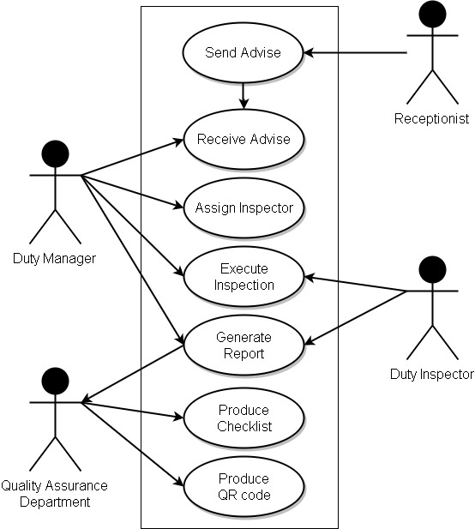

Figure 6.3 Use Case Diagram of Facilities Inspection

**Use Case Narrative Report**

|  |  |  |
| --- | --- | --- |
| Use Case Name  **Produce Quick Response (QR) Code** | |  |
| Description  Production of QR Code | | |
| Actor/s  QA Department | | |
| Precondition/s  1. Programmers should have filled the Quick Response (QR) Code with the specific data. | | |
| Main Success Scenario: | | |
| Step | Activity | |
| 1 | QA will give the Quick Response (QR) Code with the required data on it. | |

|  |  |  |
| --- | --- | --- |
| Use Case Name  **Produce Checklist** | |  |
| Description  Downloading of the checklists. | | |
| Actor/s  Inspectors | | |
| Precondition/s   1. Inspectors should have logged in the system. 2. Application is open. | | |
| Main Success Scenario: | | |
| Step | Activity | |
| 1 | Inspector will now scan the Quick Response (QR) Code. | |
| 2 | System will verify the credentials of the logged user. | |
| 3 | System display fields  -Username  -Time started  -Checklist | |

|  |  |  |
| --- | --- | --- |
| Use Case Name  **Assign Schedule** | |  |
| Description  Assigning of schedule to each inspector. | | |
| Actor/s  QA Department | | |
| Precondition/s   1. Inspector should be available on the date of the inspection. | | |
| Main Success Scenario: | | |
| Step | Activity | |
| 1 | QA will assign inspector. | |

|  |  |  |
| --- | --- | --- |
| Use Case Name  **Execute Inspection** | |  |
| Description  Start and end of inspection | | |
| Actor/s  Inspectors | | |
| Precondition/s   1. Inspectors should have logged in the system. 2. Application is open. 3. Assigned inspector should be the one on the facility. 4. Android Mobile phone 5. Inspector should be registered in the database. | | |
| Main Success Scenario: | | |
| Step | Activity | |
| 1 | Inspector will now scan the Quick Response (QR) Code. | |
| 2 | System display fields  -Username  -Password | |
| 3 | Inspector insert username and password | |
| 4 | System will verify the credentials of the inspector. | |
| 5 | Provide the checklist if username and password are correct. | |
| 6 | System display fields  -Username  -Time started  -Checklist | |
|  | Alternate Scenario | |
| Step | Activity | |
| 1 | System display fields  -Username  -Password | |
| 2 | Inspector insert username and password | |
| 3 | System will verify the credentials of the inspector. | |
| 4 | If the credentials are invalid, system will display error message and will clear all fields. | |

|  |  |  |
| --- | --- | --- |
| Use Case Name  **Generate Result** | |  |
| Description  Generating gathered results | | |
| Actor/s  Inspector | | |
| Precondition/s   1. Inspector is finished inspecting 2. All the Quick Response (QR) Code in the checklist are scanned. 3. Inspector is in main menu | | |
| Main Success Scenario: | | |
| Step | Activity | |
| 1 | Inspector scans the first Quick Response (QR) Code to trigger the time out and upload the checklist. | |
| 2 | System display  -Username  -Filtered checklist  -Timeout  Are you sure you want to end the inspection? | |
| 3 | Inspector will tap the “yes” button | |
| 4 | System will end the inspection and generate report | |
| 5 | System will now send the report to the administrator. | |
|  | Alternate scenario | |
| Steps | Activity | |
| 1 | System display  -Username  -Filtered checklist  -Timeout  Are you sure you want to end the inspection? | |
| 2 | Inspector will tap the “no” button | |
| 3 | System will go back to main menu | |

|  |  |  |
| --- | --- | --- |
| Use Case Name  **Conduct Final Inspection** | |  |
| Description  Double checking the facility if there are missed points. | | |
| Actor/s  Inspector | | |
| Precondition/s   1. Inspector should have not clicked the submit button 2. Inspector should be logged in 3. It should not quit the application | | |
| Main Success Scenario: | | |
| Step | Activity | |
| 1 | Inspector will go all over again around the facility to inspect once more for final checking. | |
| 2 | After inspecting and everything is fine, inspector will now scan the first Quick Response (QR) Code. | |
| 3 | System display  -Username  -Filtered checklist  -Timeout  Are you sure you want to end the inspection? | |
| 4 | Inspector will tap the “yes” button | |
| 5 | System will end the inspection and generate report | |
| 6 | System will now send the report to the administrator. | |
|  | Alternate scenario | |
| Steps | Activity | |
| 1 | System display  -Username  -Filtered checklist  -Timeout  Are you sure you want to end the inspection? | |
| 2 | Inspector will tap the “no” button | |
| 3 | System will go back to main menu | |

Table 6.3 Use Case Narrative Report of Facilities Inspection

**Use Case Stories**

|  |  |  |
| --- | --- | --- |
| **As a** | **I am the one who** | **So that** |
| Quality Assurance Department | produce QR code for every facility | the hotel can monitor the period of inspection |
| Quality Assurance Department | sets checklist for every facility | there will be a quality standard to follow |
| Quality Assurance Department | collects all the reports from inspection and addressing issues to compile it as one | the hotel can make a proper decision base of overall report |
|  | | |
| Duty Manager | receives technical issues from different department | the hotel can immediately address the issues |
| Duty Manager | set and assign schedule of each inspector | there will be an inspection |
| Duty Manager | perform general inspections of every facility | the hotel can assure the quality of each facility and monitor if the inspectors are inspecting properly |
| Duty Manager | generates general reports of each facility | there will be a general basis of what needs to improve in the hotel |
|  | | |
| Duty Inspector | perform technical inspections and address issues of every facility | the hotel can assure that every facility is functioning properly |
| Duty Inspector | generates technical reports of each facility | there will be a detailed basis what is needed to improve and needed to maintain in the hotel |

Table 6.2 Use Case Stories of Facilities Inspection

**Activity Diagram**

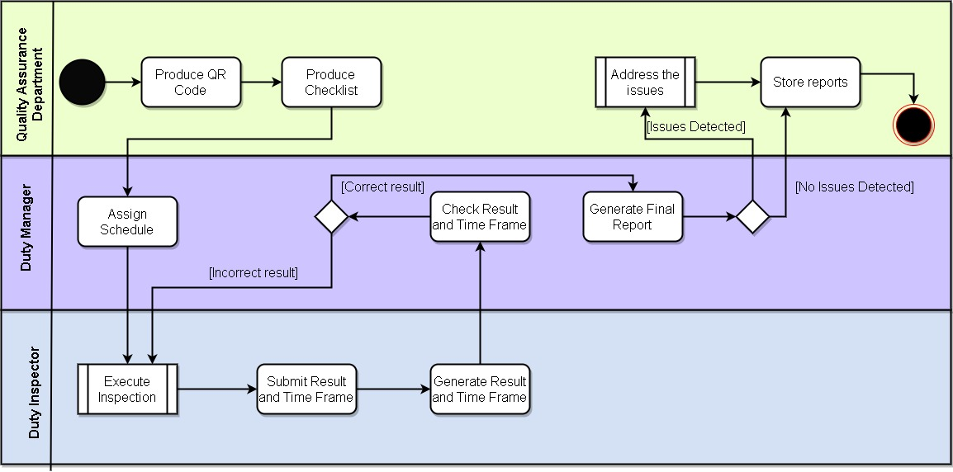

Figure 6.4 Activity Diagram of Facilities Inspection

**Execute Inspection**

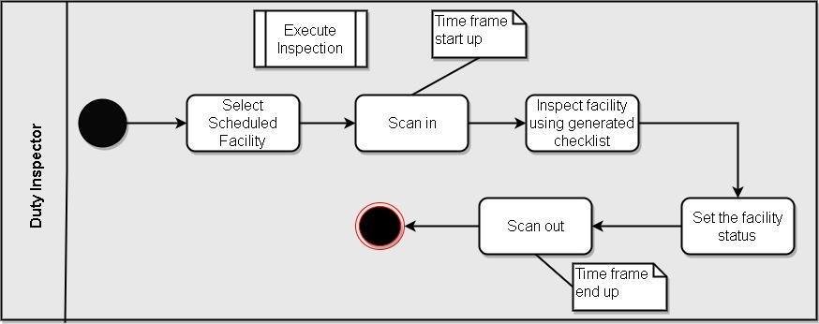

Figure 6.5 Activity Diagram - Execute Inspection of Facilities Inspection

**Address Issue**

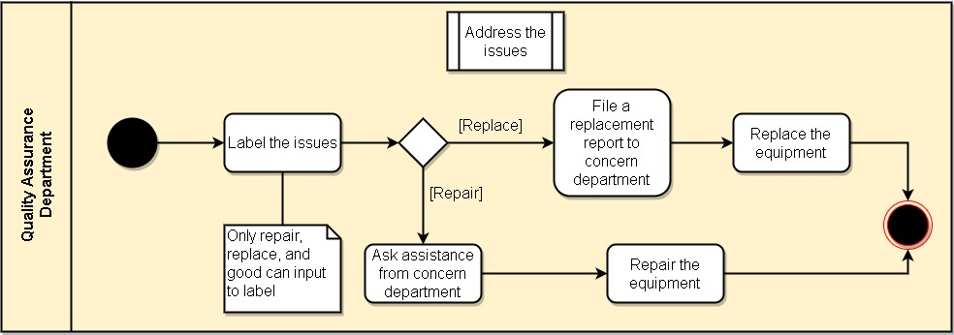

Figure 6.6 Activity Diagram - Address Issue of Facilities Inspection

**Emergency Inspection**

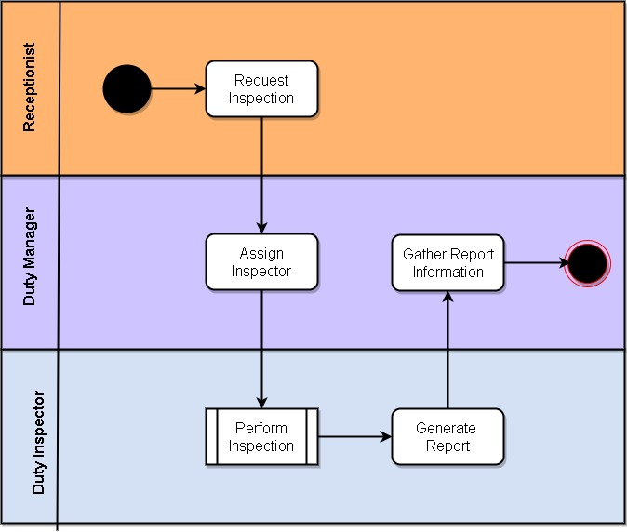

Figure 6.7 Activity Diagram - Address Issue of Facilities Inspection

**Class Diagram**

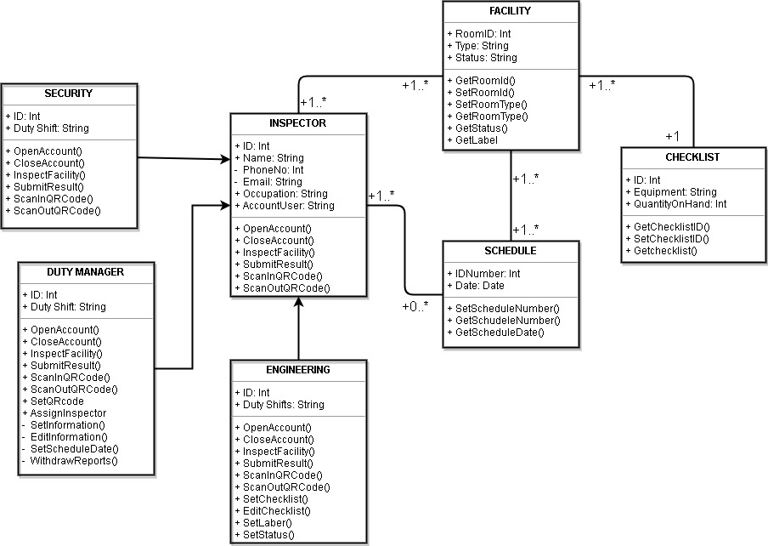

Figure 6.8 Class Diagram of Facilities Inspection

**Sequence Diagram**

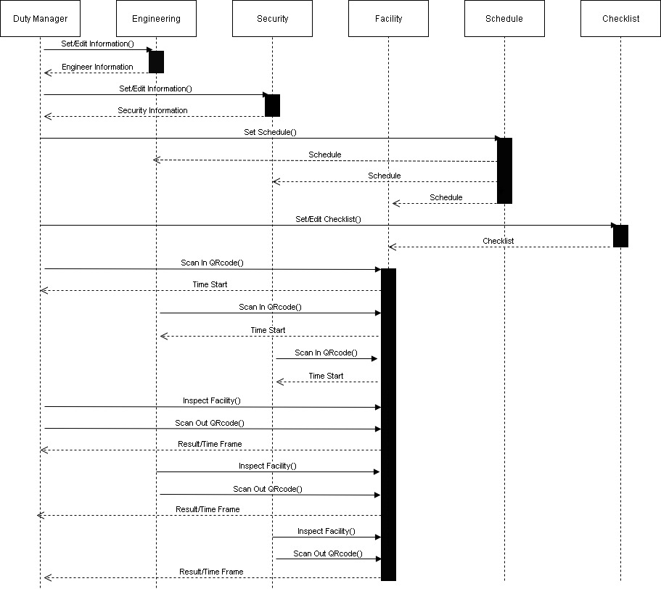

Figure 6.9 Sequence Diagram of Facilities Inspection

**6.2 Gap Analysis**

Table 6.3 Gap Analysis of Facilities Inspections

|  |  |  |
| --- | --- | --- |
| Current Situation | Future State | Proposal |
| The Quality Assurance Department cannot monitor the Duty Inspectors if he/she properly executing his/her job. | The SM Hotel can be assured whether the inspector is properly inspecting the facility by real time checking of inspection period. | Develop an application that can detect the period when the inspector inspects, by using QR code a time trigger |
| The Quality Assurance Department cannot address the issues immediately. | The SM Hotel can monitor and immediately address issues of facility | Develop an application that can store results in real time |